

**Monetary Policy Challenges Facing a New MPC Member**

Speech given by

David Walton, Member of the Monetary Policy Committee, Bank of England

At a lunch with the Exeter business community, in Exeter 16 September 2005

I am grateful to Peter Andrews, Kate Barker, Charlie Bean, Spencer Dale, Phil Evans, Richard Harrison, Richard Lambert, David Lodge, Lavan Mahadeva, Alex Muscatelli, Stephen Nickell, Jumana Saleheen and Ryland Thomas for their helpful comments.

1

All speeches are available online at [www.bankofengland.co.uk/publications/Pages/speeches/default.aspx](http://www.bankofengland.co.uk/publications/Pages/speeches/default.aspx)

It has been 2½ months since I joined the Monetary Policy Committee. This is my first regional visit and my first opportunity to reflect publicly on some of the issues faced by the MPC in this period. I am grateful to Kevin Butler, the Bank of England’s regional Agent for the South-West of England, for arranging both.

The Bank’s regional Agents, with their extensive network of contacts in the business community, are a rich source of intelligence for the MPC. Kevin and his colleagues do a tremendous job filtering and synthesising the information they receive, making it an integral part of the monthly monetary policy round. I have valued the opportunity to learn from the insights of local business people this morning and I’m looking forward to many more occasions in future. I’m confident that such contacts enable the MPC to be quick to spot any marked change in business conditions, for better or worse.

It has been a very interesting, and challenging, time to join the MPC. In July, at my first meeting, the Committee voted by a margin of 5 to 4 to leave interest rates unchanged. In August, it voted by the same margin to cut interest rates from 4¾ per cent to 4½ per cent. I voted for a 25 basis points cut at both meetings. Though the outcome of each of these meetings was as expected in financial markets, the closeness of the vote was not.

I would like to elaborate on, what for me, were some of the key judgements that the Committee had to make at the July and August meetings, and explain what led me to believe that an interest rate cut was appropriate.

I’d like to frame these thoughts in the context of the news that arose for the Committee between the May and August Inflation Reports. There were three significant sources of news.

First, extensive revisions to the national accounts meant that the *level* of market sector output was higher than previously thought (Chart 1). Over the period 1999 to the end of 2003, the average level of output was revised ½ per cent higher relative to the data available to the Committee in May. Since revisions to output more than a couple of years past should already have affected inflation, the Committee’s collective judgement was that potential output had also been around ½ per cent higher over this period.

At the same time, the data showed a more pronounced slowdown in *growth* since

mid-2004 than previously thought. As a result, the level of market sector output in the second quarter of 2005 was virtually the same as expected by the MPC in May.

Overall, the Committee judged that the economy was operating more or less at potential.

Chart 1: Revisions to the level of market sector output*

Per cent

1.5

1.2

0.9

0.6

0.3

0.0

-0.3

1992 1994 1996 1998 2000 2002 2004

*Comparison of market sector output estimates pre- and post-*Blue Book*. Market sector output is defined here as the average measure of gross value added excluding the public administration, defence, social security, education and health sectors. The estimate of market sector output for 2005 Q1 was based on information in the preliminary GDP release for 2005 Q1 available at the time of the May *Report.*

Doubtless, there will be more revisions, in time, to recent data. In the past, there has been a tendency for early estimates of GDP growth to be revised higher, and it is probably the case that growth has been stronger over the past year than official estimates currently show. Business surveys, for instance, have pointed to greater momentum in the economy in recent quarters than official data, particularly in the service sector. However, if we take into account the gradual easing in the labour market seen this year, and the stability of wage inflation, I think it is reasonable to believe that growth has been a bit below trend over the past year and this has generated a small amount of slack.

The second piece of news was the sharper than expected pickup in consumer price inflation. This continued the run of surprises to the upside that had occurred since the beginning of the year. From a low of 1.1 per cent as recently as September 2004, consumer price inflation rose to the inflation target of 2.0 per cent in June – the figure available at the August MPC meeting. It has since risen to 2.4 per cent.

Between one-third and one-half of the rise in inflation can be attributed to the effects of higher oil prices, both the direct effect on petrol prices and the indirect effects working through the supply chain. The Committee also took the view, following the national accounts revisions, that the pressure of demand on supply may have been greater than previously believed during 2003 and early 2004 and this had contributed to the upward pressure on inflation observed over the past year.

The third, and perhaps most significant, piece of news between May and August was a substantial movement in asset prices and a marked shift in interest rate expectations. The sterling exchange rate index depreciated by more than 3 per cent and equity prices were about 6 per cent higher than expected. Ahead of the August MPC

meeting, the market yield curve implied a fall in official interest rates to around 4 per cent over the next 12 months; in May, market expectations were for official interest rates to remain around 4¾ per cent. These developments had a significant impact on the MPC’s economic projections, pushing up inflation by around three-quarters of a percentage point at the two year horizon, relative to the May forecast.

At the August MPC meeting, there was broad agreement within the Committee that the interest rate market had got ahead of itself by pricing in almost three 25bp cuts in official rates by next spring. This was reflected in the Committee’s central projection for inflation which, when conditioned on the market’s implied path for official interest rates, showed inflation above target in two years time and rising (Chart 2).

Chart 2: August *Inflation Report* CPI projection based on market interest rate expectations*

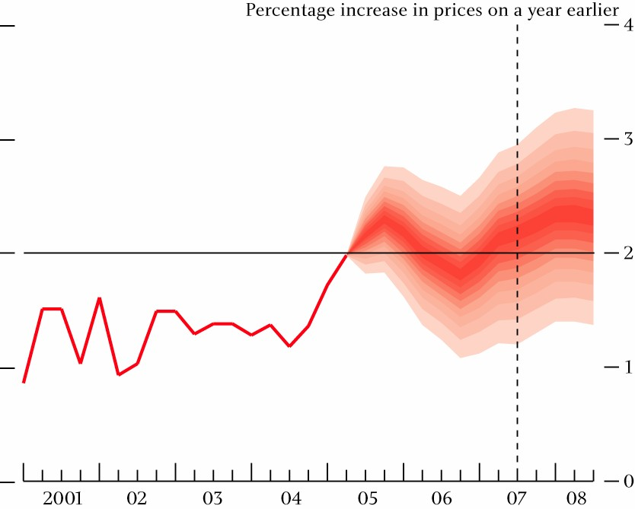

*The fan chart depicts the probability of various outcomes for CPI inflation in the future. If economic circumstances identical to today’s were to prevail on 100 occasions, the MPC’s best collective judgement is that inflation over the subsequent three years would lie within the darkest central band on only 10 of those occasions. The fan charts are constructed so that outturns of inflation are also expected to lie within each pair of the lighter red areas on 10 occasions.

Consequently, inflation is expected to lie somewhere within the entire fan chart on 90 out of 100 occasions. The dashed line is drawn at the two-year point.

By contrast, when the Committee conditioned its forecast on unchanged interest rates

– either at 4¾ per cent or 4½ per cent – inflation was close to target in two years time and remained there (Chart 3). While there is no mechanical link between these projections and policy decisions, they indicated that a case could be made for leaving rates unchanged or cutting them by 25 basis points. As is clear from the 5-4 vote, it was a close call.

Chart 3: August *Inflation Report* CPI projection based on constant nominal interest rates at 4.5%*

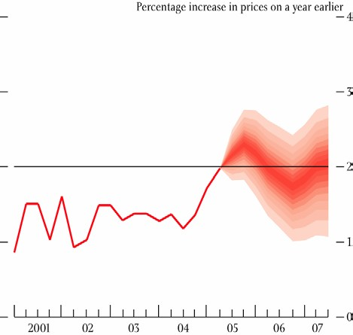

*See footnote to Chart 2 above.

I will give you three reasons why I voted for a cut in interest rates in July and August and explain why I continue to believe that this was the appropriate course of action.

First, there is a downside risk to the Committee’s central projection for growth which, in turn, creates a downside risk for inflation further out. Household spending growth, in particular, has been very weak during the first half of this year. Although these data could yet be revised higher, a further period of subdued consumption growth seems quite likely. Higher oil prices and a loosening in the labour market will curb the growth of household real incomes. And households’ willingness to borrow to maintain spending growth may be limited by their existing high levels of debt and the low level of the savings ratio. Business investment prospects are also very uncertain. Companies may remain reluctant to invest in the face of increased uncertainty about demand and profitability associated with high energy prices.

Second, the rise in inflation over the past year needs to be kept in perspective. Despite the severity of the oil shock, inflation is only a little above its *symmetric* target of 2 per cent after a prolonged period in which inflation has been below target. Part of the rise might be idiosyncratic: consumer price inflation has picked up more sharply than RPIX inflation, for instance (Chart 4). Nevertheless, inflation is likely to remain above target in the next few months as the full effects of higher oil prices are felt. In this period, we must be vigilant for we cannot take the stability of inflation expectations for granted. But monetary policy must also be forward looking. If monetary policy reacts to actual inflation, rather than anticipating future inflation, it risks doing too little too late or too much too late. The slowdown in growth over the past year should lead to some moderation in inflationary pressure further ahead. The stability of wage inflation and the decline in cost and price pressures across a range of business surveys in recent months suggest that, for the moment at least, any second round effects from higher oil prices will be modest.

Chart 4: CPI and RPIX inflation*

Percentage change on a year earlier

**RPIX**

**CPI**

3.5

3

2.5

2

1.5

1

0.5

0

1997 1998 1999 2000 2001 2002 2003 2004 2005

*Until December 2003, the target for monetary policy was 2.5% for RPIX inflation. Since then, the target has been 2.0% for CPI inflation

Third, if it were not for the asset price movements observed between May and August, the Committee would have been faced with the prospect of an undershoot in the inflation target two years ahead. Some of the easing in financial conditions that had taken place, particularly the decline in the exchange rate, was likely to have been in anticipation of lower interest rates. Since a 25bp rate cut was consistent, on our central projection, with achieving the inflation target in two years time, I saw no merit in surprising financial markets unnecessarily. To keep inflation on target, I judged it necessary to validate at least part of the market expectation for lower interest rates.

Since the August MPC meeting, the sterling exchange rate index has recovered by around 2½ per cent and this should help to keep inflation on target.

So much for the past. In concluding, let me give a few brief thoughts about the future. The MPC’s forecasts in the August Inflation Report painted a fairly benign picture for the UK economy. On unchanged interest rates, the Committee expects growth to recover steadily back to trend over the next year (Chart 5) and inflation to remain close to target. Of course, the chances of the MPC’s central projections being correct are extremely low. But they provide a useful benchmark for how I, and my colleagues on the Committee, will interpret the flow of news in coming months.

Chart 5: August *Inflation Report* GDP projection based on constant nominal interest rates at 4.5%*

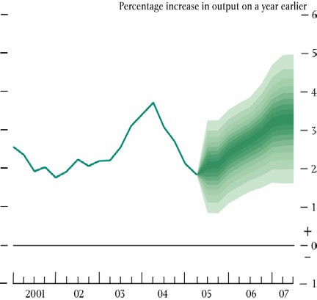

*The fan chart depicts the probability of various outcomes for GDP growth in the future. If economic circumstances identical to today’s were to prevail on 100 occasions, the MPC’s best collective judgement is that GDP growth over the subsequent three years would lie within the darkest central band on only 10 of those occasions. The fan charts are constructed so that outturns of GDP growth are also expected to lie within each pair of the lighter green areas on 10 occasions. Consequently, GDP growth is expected to lie somewhere within the entire fan chart on 90 out of 100 occasions.

Oil is a big uncertainty for the outlook for both growth and inflation. Increasingly, the shock from oil prices seems larger and more permanent than expected. Oil prices have doubled since the beginning of 2004; the oil futures market suggests that much of this increase in prices may persist. High oil prices act like a tax, transferring money from consumers to oil producers, leaving many of us worse off.

The appropriate monetary policy response depends on how households and businesses react. There is a wide range of possible outcomes. Demand could conceivably soften too much if business and consumer confidence are damaged. Inflation expectations could become destabilised if inflation moves too far away from target. And some productive capacity could be lost permanently. When thinking about my recommendation for interest rates in coming months, I will be considering carefully how each of these will affect the chances of meeting the inflation target.

If I have left you feeling uncertain about the future course of interest rates, then you are in good company. The one certainty is that the MPC will continue to set interest rates each month at the level it judges appropriate to keep inflation on track to meet the 2 per cent target. I am very pleased to have been appointed to the Committee to be able to participate in that decision making process.